Staff Troubleshooting

Use the drop-downs below to answer common questions

Exploration Helpdesk
You can contact Innovative Solutions:
Available Monday-Friday between 9:00am - 3:00pm
Enter a ticket here

Creating Videos with SMART Notebook Recorder
Getting Started
Click on the Show Hidden icons in the bottom right of your computer
Click on the SMART Notebook Tools
Click on Recorder 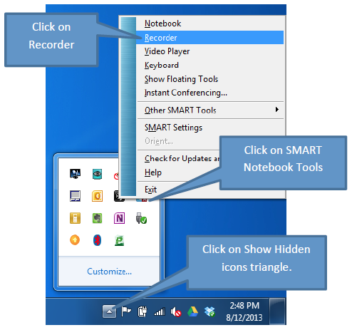

Three Settings
Record Desktop (Default) Captures the whole desktop
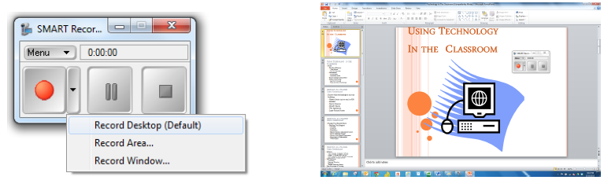

Record Area Lets you select what section of desktop you want to record by drawing a rectangle
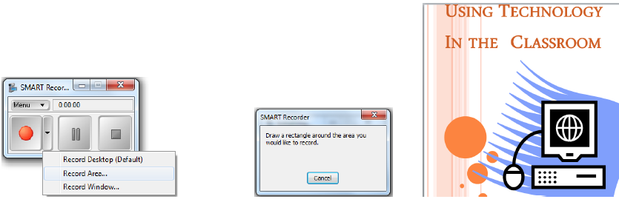
Record Window Select a window you want to record
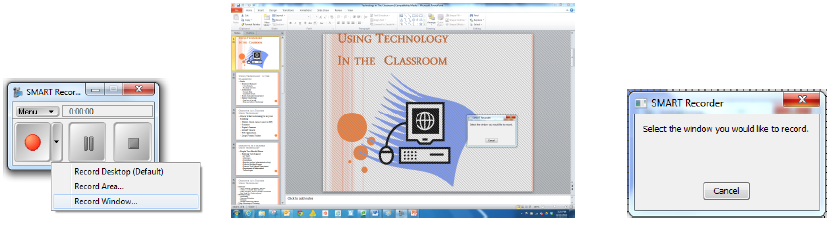

Start Recording
Click the record button. Minimize the SMART Recording Tool.
2: 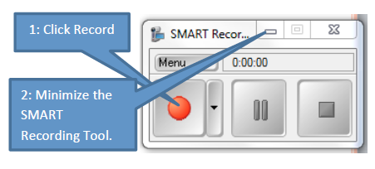
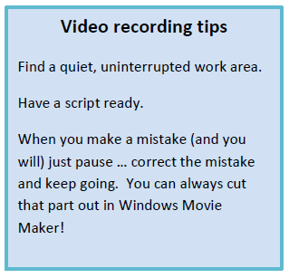
Stop and Save Recording
Select the Folder
Change file name (save as video topic)
Click on Save
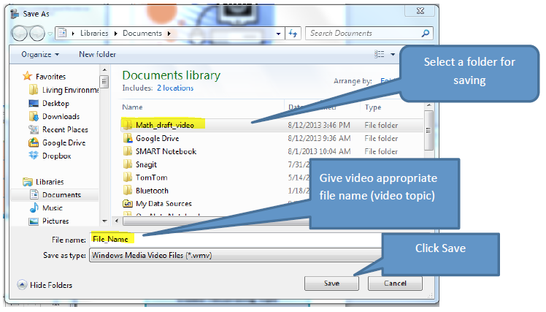

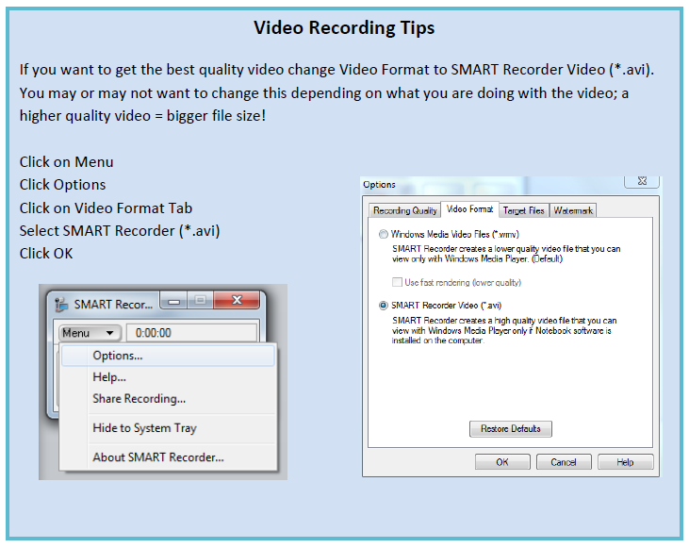

Connecting Virtually
Use the instructions below to connect with students or colleagues.

Zoom Video Conferencing (connect with colleagues or students) *accounts set up for all staff

Zoom. How to guide

Microsoft Teams (connect with colleagues)
To learn the basics: Microsoft Teams. How to guide

How to use Zoom with Clever:
https://www.youtube.com/watch?v=dy6HuDvaRiU

